Project: Test Plan
Course: CSD380 - DevOps
Description: Todo app testing.
Date: 2026/01/14
To complete the test case plan, fill out the information for Project, Course, Description and Date in the header below.
.
TABLE OF CONTENTS
Allow users to access the website through a standard URL. 2
Create Task 2
Edit Task 3
Delete Task 4
Preventing Empty Submission 5

For each test, the developer should: provide a test description, a test objective, the developer name and date tested. For each step, fill out the actions to be taken and describe the expected results, and indicate yes or no for each step depending upon the result. The peer tester should provide their name, date tested, indicate yes or no for each step depending upon the result, and a screenshot (thumbnail) of the result.

Test 1 | Allow users to access the website through a standard URL.
 | Test Objective: Allow users to access the website with the standard URL: https://buwebdev.github.io/todo | Developer: Brennan Cheatwood  Date tested: <2026/01/14> | Peer tester: M. Michaels  Date tested: 2026/01/18
Step | Action | Expected results: | Developer pass/fail | Tester pass/fail
1 | Visit https://buwebdev.github.io/todo in a web browser. | The page will display without errors. | Yes | Yes  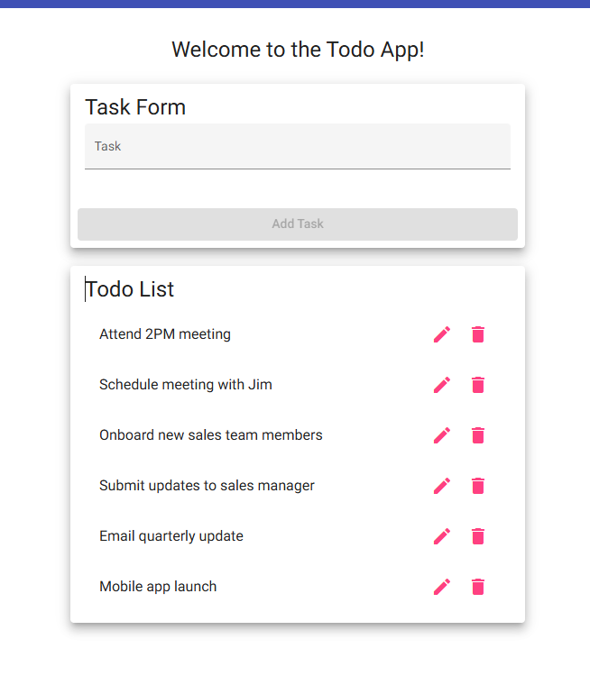
2 | Refresh the browser window | The page will refresh without errors. | Yes | Yes
Comments

Test 2 | Create Task
 | Test Objective: Create a new todo task item. | Developer: Brennan Cheatwood  Date tested: 2026/01/14 | Peer tester: M. Michaels  Date tested: 2026/01/18
Step | Action | Expected results: | Developer pass/fail | Tester pass/fail
1 | Click underneath “Task Form” to input text | The Task Form will allow the user to input text | Yes | Yes  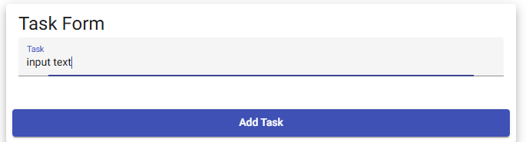
2 | Click “Add Task” once text is entered | The text entered inside the task form will appear in the Todo List section. | Yes | Yes  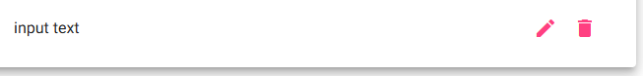
Comments | Comments should be substantive; this means there should be at least 2-3 well-structured sentences with constructive feedback.

Test 3 | Edit Task
 | Test Objective: Edit a todo task item. | Developer: Brennan Cheatwood  Date tested: <2026/01/14> | Peer tester: M. Michaels  Date tested: 2026/01/18
Step | Action | Expected results: | Developer pass/fail | Tester pass/fail
1 | Click the pencil icon on a task | An “Edit Form” dialogue window will appear giving the option to edit the text of the task. | Yes | Yes  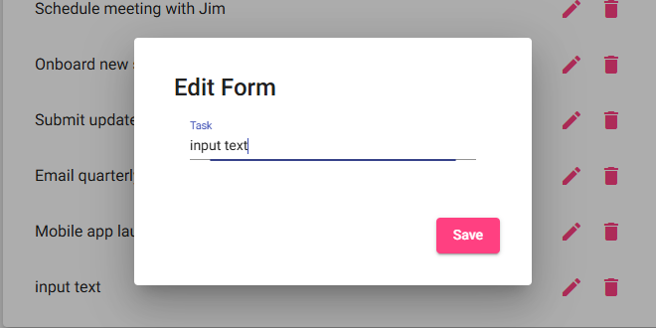
2 | Click “Save” once the text is edited. | The updated text will appear on the Todo List. | Yes | Yes  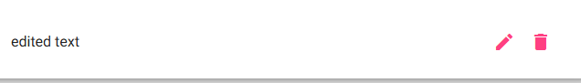
Comments | Comments should be substantive; this means there should be at least 2-3 well-structured sentences with constructive feedback.

Test 4 | Delete Task
 | Test Objective: Delete a todo task item. | Developer: Brennan Cheatwood  Date tested: <2026/01/14> | Peer tester: M. Michaels  Date tested: 2026/01/18
Step | Action | Expected results: | Developer pass/fail | Tester pass/fail
1 | Click the Trash icon on a desired task | The selected task will be removed from the list immediately. | Yes | Yes  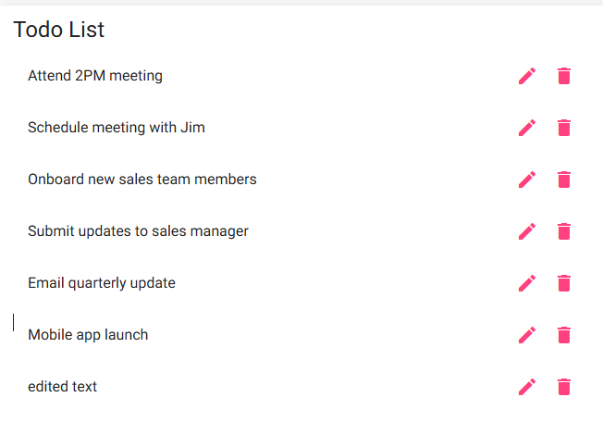
2 | Ensure the Todo List is updated accordingly. | The todo list will be updated and the previously selected task will not appear. | Yes | Yes  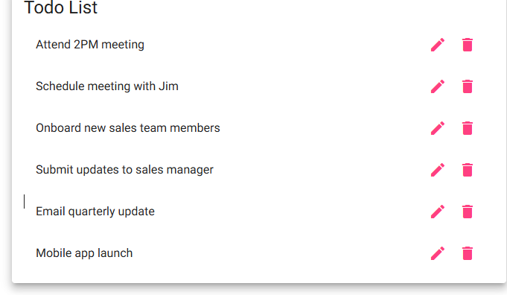
Comments

Test 5 | Preventing Empty Submission
 | Test Objective: Prevent users from submitting a task form without entering a todo item | Developer: Brennan Cheatwood  Date tested: <2026/01/14> | Peer tester: M. Michaels  Date tested: 2026/01/18
Step | Action | Expected results: | Developer pass/fail | Tester pass/fail
1 | Leave submission form blank | The “Add Task” button will stay grey | Yes | Yes  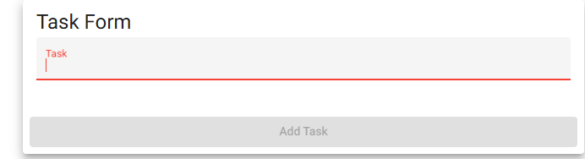
2 | Click the greyed-out “Add Task” button to ensure submission isn’t possible. | Nothing will happen when the button is clicked. | Yes | Yes  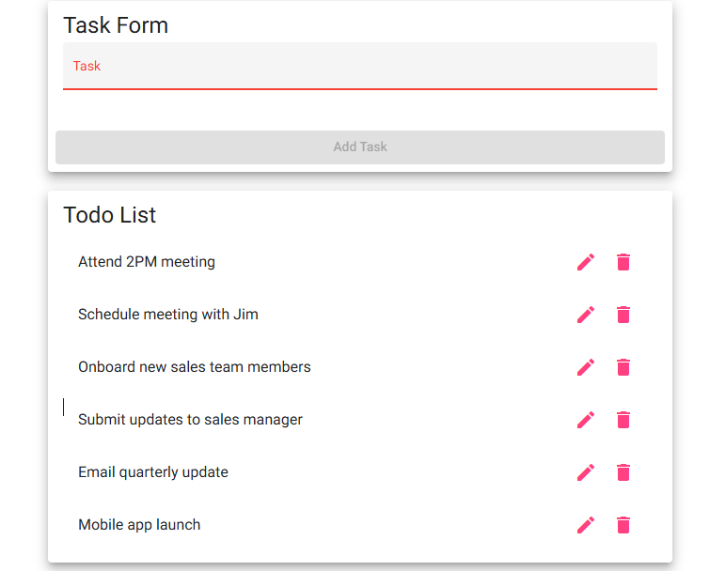
Comments

